**Speech Therapy Assessment Application**

1Mr. Chirag Chawade

*Department of Information Technology*

*BRACT Vishwakarma Institute of Information Technology Pune, India*

chirag.22010070@viit.ac.in

2Mr. Niraj Amrutkar

*Department of Information Technology*

*BRACT Vishwakarma Institute of Information Technology Pune, India*

niraj.22010910@viit.ac.in

4Mr. Harsh Chawla

*Department of Information Technology*

*BRACT Vishwakarma Institute of Information Technology Pune, India*

harsh.22010826@viit.ac.in

5Dr. Aparna Junarkar

*Prof. Department of Information Technology*

*BRACT Vishwakarma Institute of Information Technology Pune, India*

aparna.junarkar@viit.ac.in

3Mr. Suniket Khairnar

*Department of Information Technology*

*BRACT Vishwakarma Institute of Information Technology Pune, India*

suniket.22010917@viit.ac.in

Abstract *– This research explores the development and implementation of a client-server mobile application designed to facilitate the diagnosis and therapeutic intervention for individuals with autism spectrum disorder (ASD). The application serves as a collaborative platform connecting healthcare professionals (doctors) and their patients, streamlining the diagnostic process, therapeutic assignment, and progress monitoring. The app operates on a client-server architecture, where doctors, serving as administrators, study patients within clinical settings. Subsequently, doctors assign personalized practice cards to patients for targeted skill development. To assess patient progress, doctors create Multiple-Choice Question (MCQ) tests associated with specific cards, integrating visual and auditory stimuli for a comprehensive evaluation. Patients, utilizing a secure client-side interface, interact with assigned cards and undertake MCQ tests that incorporate both visual stimuli and audio cues. The app fosters an engaging and interactive environment, enhancing the learning experience for individuals with ASD.*

*Key features of the app include a centralized dashboard for doctors to manage multiple patients, review assignment scores, and monitor overall progress. Additionally, a secure parent monitoring feature enables caregivers to access pertinent information with a unique code, fostering collaborative care between healthcare professionals and families. This research delves into the technical aspects of the app, incorporating technologies such as Cloudinary for multimedia management, SQL for database functionality, and React Native for cross-platform mobile development. Methodology includes a comprehensive exploration of the system design, implementation details, and user feedback.*

# INTRODUCTION

## Background and Context of the Study:

Autism Spectrum Disorder (ASD) represents a complex neurodevelopmental condition characterized by challenges in social interaction, communication, and repetitive behaviors. As the prevalence of ASD continues to rise, there is a growing need for innovative and accessible interventions to support individuals diagnosed with this disorder.

This research addresses this need by presenting a mobile application designed to facilitate the diagnostic and therapeutic journey for individuals with ASD. The application employs a client-server architecture, creating a collaborative platform connecting healthcare professionals and patients.

## Importance of the Research:

The significance of this research lies in its response to the challenges faced by healthcare professionals, particularly doctors, in efficiently diagnosing and intervening in ASD. Traditional methods often lack the interactive and personalized elements crucial for engaging individuals with ASD in therapeutic activities. This research seeks to bridge this gap by harnessing the potential of mobile technology to enhance the diagnostic process and therapeutic interventions.

The application's focus on individualized practice cards, multimedia-enhanced assessments, and secure parent monitoring addresses the multifaceted needs of both healthcare professionals and caregivers. By leveraging technology, this research aims to contribute to the evolving landscape of ASD interventions, emphasizing the importance of collaborative and accessible tools in providing comprehensive care.

## Purpose of the App:

The purpose of the developed mobile application is to create a seamless and interactive environment for doctors and patients involved in the diagnosis and treatment of ASD. The app enables doctors to study patients within clinical settings, assign personalized practice cards, and conduct multimedia-enhanced assessments, fostering targeted skill development.

Patients, in turn, benefit from an engaging platform that integrates visual and auditory stimuli into therapeutic activities. The app's architecture allows for secure parent monitoring, promoting collaborative care and extending the learning experience beyond clinical sessions.

## Objectives of the Research Paper

This research paper aims to achieve the following objectives:

Explore the development and implementation of the client-server mobile application for ASD intervention.

Examine the technical aspects of the app, including the use of Cloudinary for multimedia management, SQL for database functionality, and React Native for cross-platform mobile development.

Investigate the effectiveness of the app in enhancing the diagnostic process and therapeutic interventions for individuals with ASD.

Evaluate user feedback to understand the usability, impact, and potential improvements of the application.

Contribute insights to the broader field of technology-assisted interventions for ASD, emphasizing the role of collaborative platforms in personalized care.

# LITERATURE SURVEY

A comprehensive examination of recent literature on Autism Spectrum Disorder (ASD) illuminates critical facets of this complex condition. Genetic studies have underscored the high heritability of ASD and highlighted the variability within normal development, emphasizing the importance of understanding specific genes contributing to susceptibility

[1] Concurrently, research has focused on mobile applications tailored for ASD, acknowledging their significance in clinical settings. Evaluations of existing mobile apps for ASD have proven pivotal, guiding clinicians and families toward evidence-based interventions

[2] Notably, interventions like the Puzzle Walk app and tablet apps from Open Autism Software have demonstrated the potential of technology in enhancing physical activity and social interactions among individuals with ASD

[3]

[4] Furthermore, participatory design approaches have yielded educational mobile apps that are instrumental in improving numeracy skills, emphasizing the necessity for tailored tools in addressing diverse ASD needs

[5] Studies delve into innovative methods for ASD interventions, including Applied Behavior Analysis (ABA) techniques like Discrete Trial Instruction (DTI), mand training, and Natural Environment Teaching (NET). These approaches have provided valuable insights into effective teaching methodologies for individuals with ASD, particularly within inclusive school settings

[6] Moreover, environmental factors have come under scrutiny, revealing possible links between pollutants, advanced parental age, older siblings with ASD, and increased risk for autism

[7] This knowledge underscores the multifaceted nature of ASD, necessitating holistic interventions that consider both genetic predispositions and environmental influences.

The integration of Information and Communication Technology (ICT) in ASD interventions has marked a significant stride. Recent reviews have highlighted the importance of early development interventions, focusing on imitation and joint attention, facilitated by robotics and interactive applications

[8] Categorized into diagnostic tools, intervention tools, and mobile apps, these technological advancements represent a beacon of hope. Notably, Augmentative and Alternative Communication (AAC) tools like Picture Exchange Communication System (PECS) have showcased positive outcomes, improving communication skills and aiding in adapting to normal life

[9] As technology continues to evolve, these findings underscore the transformative potential of innovative interventions, offering promise for individuals with ASD and their families in navigating the challenges associated with the disorder.

**Table No. 1**: - Literature Surveys

|  |  |  |
| --- | --- | --- |
| Sr No | Paper No | Name |
| 1 | 1 | Autism Spectrum Disorders By Catherine Lord ‡ Edwin H. Cook, Bennett L. Leventhal, and David G. Amaral |
| 2 | 2 | Smartphone Apps for Autism Spectrum Disorder—Understanding  the Evidence  Jung Won Kim1 & Thuc-Quyen Nguyen2 & Shih Yee-Marie Tan Gipson3 & Ah Lahm Shin1 & John Torous4 |
| 3 | 3 | Puzzle Walk: A Gamified Mobile App to Increase Physical Activity in Adults with Autism Spectrum Disorder |
| 4 | 4 | Evaluation of Tablet Apps to Encourage Social Interaction  in Children with Autism Spectrum Disorders  Juan Pablo Hourcade, Stacy R. Williams, Ellen A. Miller, Kelsey E. Huebner, Lucas J. Liang |
| 5 | 5 | Development of a Mobile App to Improve Numeracy Skills of Children With Autism Spectrum Disorder: Participatory Design and Usability Study Theoneste Ntalindwa 1 , MSc; Mathias Nduwingoma1 , PhD; Evariste Karangwa 2 , PhD; Tanjir Rashid Soron3 , MD, MPH, MSc; Alphonse Uworwabayeho1 , PhD; Annette Uwineza4 , MD, PhD |
| 6 | 6 | Applied Behavior Analysis: Its Application in the Treatment of Autism and Related Disorders in Young ChildrenSandra L. Harris, PhD Professor of Clinical Psychology Graduate School of Applied and Professional Psychology Lara Delmolino, PhD Research Assistant Professor Douglass Developmental Disabilities Center Rutgers, The State University of New Jersey New Brunswick, New Jersey |
| 7 | 7 | Children with Autism Spectrum Disorder and Patterns of  Participation in Daily Physical and Play Activities  Amir Hossein Memari,1 Nekoo Panahi,1 Elaheh Ranjbar,1 Pouria Moshayedi,2  Masih Shafiei,1 Ramin Kordi,1 and Vahid Ziaee3 |
| 8 | 8 | MISE AU POINT/ IN-DEPTH REVIEW AUTISM IN REVIEWSimone KHALIFEH1,2,3, Walid YASSIN2,3, Silva KOURTIAN2,3,4, Rose-Mary BOUSTANY1,2,3, |
| 9 | 9 | Features of Mobile Apps for People with Autism in a Post COVID-19 Scenario: Current Status and Recommendations for Apps Using AI Ikram Ur Rehman 1 , Drishty Sobnath 2 , Moustafa M. Nasralla 3 , Maria Winnett 1 , Aamir Anwar 1 , Waqar Asif 1 and Hafiz Husnain Raza Sherazi 1, |
| 10 | 10 | Assisting Children with Autism Spectrum Disorder with Educational Mobile Apps to Acquire Language and Communication Skills: A Review Azham Hussain (*) Universiti Utara Malaysia, Sintok, Malaysia hussazham@yandex.com Emmanuel O.C. Mkpojiogu Universiti Utara Malaysia, Sintok, Malaysia Veritas University, Abuja, Nigeria Pauline Chiamaka Okoroafor Veritas University, Abuja, Nigeria |
| 11 | 11 | INCREASING COMMUNICATIVE INTERACTIONS OF YOUNG CHILDREN WITH AUTISM USING A VOICE OUTPUT COMMUNICATION AID AND NATURALISTIC TEACHING MAUREEN M. SCHEPIS FAMILY, INFANT, AND PRESCHOOL PROGRAM AND WESTERN CAROLINA CENTER DENNIS H. REID CAROLINA BEHAVIOR ANALYSIS AND SUPPORT CENTER AND LOUISIANA STATE UNIVERSITY MEDICAL CENTER MICHAEL M. BEHRMANN GEORGE MASON UNIVERSITY AND KELLY A. SUTTON WESTERN CAROLINA CENTER FOUNDATION |
| 12 | 12 | Interventions for Children With Autism Spectrum Disorders in Inclusive School Settings Lynn Koegel, Rosy Matos-Fredeen, Russell Lang, and Robert Koegel, University of California, Santa Barbar |
| 13 | 13 | Interactive Technologies for Autistic Children: A Review Sofiane Boucenna, Antonio Narzisi, Elodie Tilmont, Filippo Muratori, Giovanni Pioggia, David Cohen & Mohamed Chetouani |
| 14 | 14 | Autism Children’s App based intervention |
| 15 | 15 | Applications for Children with Autism in Preschool and Primary Education Maria Xanthopoulou (*), Georgia Kokkalia, Athanasios Drigas National Center for Scientific Research-Demokritos, Attica, Greece maxanthopoulou@yahoo.com |
| 16 | 16 | Autism Children’s App using PECS Nareena Soomro1, * and Safeeullah Soomro |

# PROPOSED METHODOLOGY

## Technologies Used:

React Native: React Native, a framework based on the React library, was employed for the development of the mobile application in this project. Leveraging JavaScript, it enables the creation of cross-platform apps for both iOS and Android, allowing for code reusability and efficiency in the development process.

Node.js: Node.js, a server-side JavaScript runtime, served as the backbone for the project's backend development. Its event-driven architecture and non-blocking I/O capabilities make it well-suited for building scalable and real-time applications. Node.js facilitated the implementation of server-side logic, enabling seamless communication between the mobile app and the database.

MySQL: MySQL, a robust relational database management system, was used to store and manage structured data for the project. It provided a reliable and scalable solution for data storage, supporting the structured organization of information such as user profiles, app content, and other relevant data.

Cloudinary: It’s a cloud-based media management platform, played a crucial role in handling images and audio assets for the application. By using Cloudinary's services, the project benefited from features such as image and video storage, optimization, and manipulation. This cloud-based solution enhanced the efficiency of managing and delivering media assets, contributing to an optimized user experience.

## Development Process:

The development process followed an iterative and collaborative approach, involving key stakeholders such as healthcare professionals, app developers, and individuals with ASD. The process encompassed the following stages:

Requirement Analysis: Detailed discussions were conducted with healthcare professionals to identify specific diagnostic and therapeutic needs. These discussions informed the creation of features, including personalized practice cards, multimedia assessments, and secure parent monitoring.

Prototyping: Prototypes were developed to visualize the app's interface and functionalities. Feedback from healthcare professionals and potential users guided iterative refinements to enhance usability and alignment with the intended objectives.

Coding and Implementation: The app was coded using React Native, leveraging its component-based architecture to ensure modular and maintainable code. Cloudinary integration facilitated the seamless handling of multimedia elements, while SQL ensured efficient data management.

Testing and Debugging: Rigorous testing procedures, including unit testing and user acceptance testing, were conducted to identify and address any technical glitches or usability issues. Iterative debugging and refinements were undertaken to enhance overall performance.

## Data Collection Methods:

The data collection process involved multiple dimensions, catering to both diagnostic and research-oriented requirements. Key data collection methods included:

Diagnostic Data: Doctors were enabled to manually create custom practice cards by adding their own voice recordings and images. This allowed for personalized therapeutic interventions tailored to the unique needs of each patient.

Assessment Data: Multiple-Choice Question (MCQ) tests incorporated into the app served as a structured means of assessing patient progress. Data collected included response times, accuracy rates, and specific areas of strength or challenge.

Class Diagram:

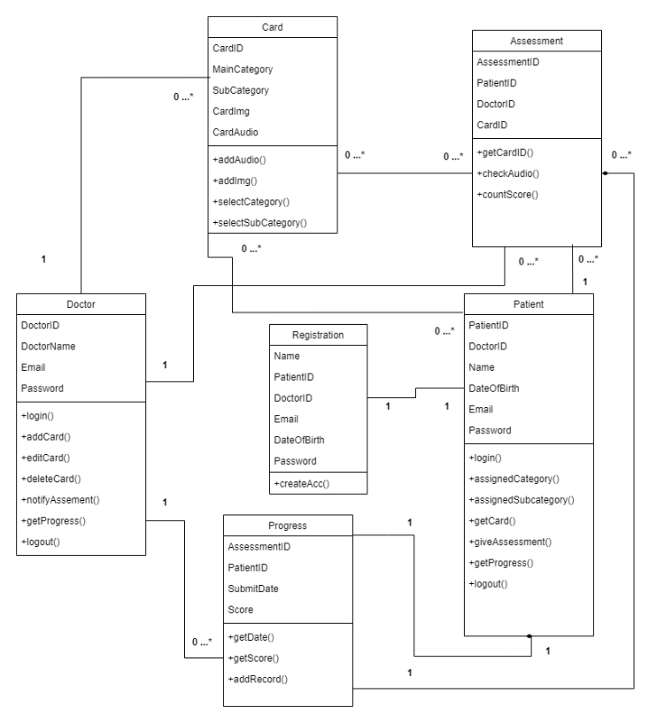

ER Diagram

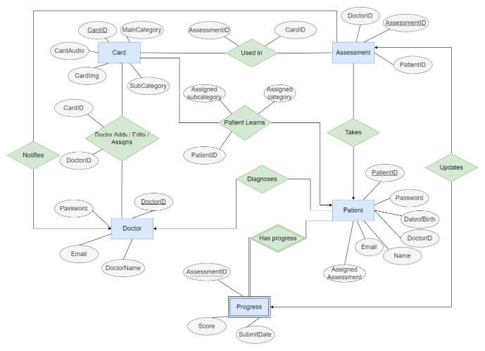

# Implementation

## Technical Details of App Development:

The app development process embraced the React Native framework, providing a cross-platform solution with a single codebase for iOS and Android platforms. Cloudinary integration facilitated efficient multimedia management, allowing for seamless storage and retrieval of images and audio files. The SQL database served as a robust backend, enabling secure data storage and retrieval for patient records, practice cards, and assessment data.

## Challenges Faced During Implementation:

Challenges encountered during implementation included:

Multimedia Integration: Integrating multimedia elements into the app, such as user-uploaded images and audio, posed challenges in ensuring optimal performance and responsiveness.

Cross-Platform Consistency: Achieving consistent user experiences across iOS and Android platforms required careful consideration of platform-specific nuances and optimizations.

Real-Time Data Sync: Ensuring real-time synchronization of data between the client-side application and the server presented challenges in maintaining data integrity and minimizing latency.

## Solutions to Overcome Challenges:

To address these challenges, proposed employed the following solutions:

Optimized Multimedia Processing: Implemented asynchronous processing for multimedia uploads to prevent performance bottlenecks, ensuring a smooth user experience.

Platform-Specific Optimization: Utilized React Native libraries and modules for platform-specific optimizations, ensuring a consistent and polished user interface across both iOS and Android.

Real-Time Data Sync Mechanism: Implemented WebSocket technology to facilitate real-time data synchronization, enhancing the responsiveness of the app and ensuring up-to-date information for both doctors and patients.

# RESULTS AND FINDINGS

## Outcomes of the Research:

The research yielded positive outcomes, with the app showcasing effectiveness in enhancing the diagnostic and therapeutic processes for individuals with autism. The user-friendly interface, personalized practice cards, and multimedia-enhanced assessments contributed to a more engaging and tailored experience for both healthcare professionals and patients.

## User Feedback and Relevant Metrics:

User feedback highlighted the app's usability, with healthcare professionals commending the ease of creating custom practice cards and conducting assessments. Metrics such as response times, accuracy rates, and progress over time provided valuable insights into the effectiveness of the app in skill development.

## Impact of the App on Users with Autism:

The app demonstrated a positive impact on users with autism, fostering skill development in a personalized and interactive manner. Users exhibited increased engagement with therapeutic activities, and the integration of visual and auditory stimuli proved beneficial in catering to diverse learning styles.

# Discussion

## Interpretation of Results and Findings:

The positive outcomes and user feedback underscore the potential of technology-assisted interventions in the realm of autism. The app's emphasis on personalization and engagement aligns with current research supporting the effectiveness of tailored interventions for individuals with ASD.

## Comparison with Existing Solutions:

Comparative analysis with existing solutions highlights the uniqueness of proposed app in providing a collaborative platform for doctors and patients. The incorporation of multimedia elements and real-time data synchronization distinguishes proposed approach, contributing to a more dynamic and responsive intervention.

## Strengths and Limitations:

Strengths of proposed approach include personalized practice cards, effective multimedia integration, and a secure parent monitoring feature. Limitations include potential challenges in internet connectivity affecting real-time sync and the need for ongoing updates to address emerging needs.

# CONCLUSION

## Main Findings:

In summary, the research affirms the positive impact of proposed client-server mobile application on the diagnostic and therapeutic journey for individuals with autism. The app's innovative features, technological foundations, and user-centric design contribute to a comprehensive solution for healthcare professionals and patients alike.

## Significance of the Research:

This research underscores the significance of leveraging technology to enhance personalized care in the field of autism interventions. The positive outcomes reaffirm the potential of collaborative and accessible tools in improving patient outcomes and caregiver engagement.

## Areas for Future Research:

Future research endeavors may explore further enhancements to the app, including the integration of additional therapeutic activities, expanded multimedia options, and adaptive learning algorithms. Additionally, longitudinal studies could provide insights into the long-term impact of the app on individuals with autism.

This research contributes to the ongoing discourse on technology-assisted interventions for autism, emphasizing the importance of collaboration, personalization, and innovation in shaping the future of healthcare practices for individuals with ASD.

# REFERENCES

1. Children with autism spectrum disorder and patterns of participation in daily physical and play activities:
2. Memari, A.H. et al. (2015) Neurology Research International.
3. "Autism Spectrum Disorders" By Catherine Lord, Edwin H. Cook, Bennett L. Leventhal, and David G. Amaral.
4. "Smartphone Apps for Autism Spectrum Disorder—Understanding the Evidence" by Jung Won Kim, Thuc-Quyen Nguyen, Shih Yee-Marie Tan Gipson, Ah Lahm Shin, John Torous.
5. "Puzzle Walk: A Gamified Mobile App to Increase Physical Activity in Adults with Autism Spectrum Disorder" - Evaluation of Tablet Apps to Encourage Social Interaction in Children with Autism Spectrum Disorders:
6. Juan Pablo Hourcade, Stacy R. Williams, Ellen A. Miller, Kelsey E. Huebner, Lucas J. Liang.
7. "Development of a Mobile App to Improve Numeracy Skills of Children With Autism Spectrum Disorder: Participatory Design and Usability Study" by Theoneste Ntalindwa, Mathias Nduwingoma, Evariste Karangwa, Tanjir Rashid Soron, Alphonse Uworwabayeho, Annette Uwineza.
8. "Applied Behavior Analysis: Its Application in the Treatment of Autism and Related Disorders in Young Children" by Sandra L. Harris, Lara Delmolino, Douglass Developmental Disabilities Center, Rutgers, The State University of New Jersey, New Brunswick.
9. "Features of Mobile Apps for People with Autism in a Post COVID-19 Scenario: Current Status and Recommendations for Apps Using AI" by Ikram Ur Rehman, Drishty Sobnath, Moustafa M. Nasralla, Maria Winnett, Aamir Anwar, Waqar Asif, Hafiz Husnain Raza Sherazi.
10. "Assisting Children with Autism Spectrum Disorder with Educational Mobile Apps to Acquire Language and Communication Skills: A Review" by Azham Hussain, Emmanuel O.C. Mkpojiogu, Pauline Chiamaka Okoroafor.
11. "INCREASING COMMUNICATIVE INTERACTIONS OF YOUNG CHILDREN WITH AUTISM USING A VOICE OUTPUT COMMUNICATION AID AND NATURALISTIC TEACHING" by MAUREEN M. SCHEPIS, DENNIS H. REID, MICHAEL M. BEHRMANN.
12. "Interventions for Children With Autism Spectrum Disorders in Inclusive School Settings" by Lynn Koegel, Rosy Matos-Fredeen, Russell Lang, and Robert Koegel, University of California, Santa Barbara.
13. "Interactive Technologies for Autistic Children: A Review" by Sofiane Boucenna, Antonio Narzisi, Elodie Tilmont, Filippo Muratori, Giovanni Pioggia, David Cohen & Mohamed Chetouani.
14. "Autism Children’s App based intervention."
15. "Applications for Children with Autism in Preschool and Primary Education" by Maria Xanthopoulou, Georgia Kokkalia, Athanasios Drigas, National Center for Scientific Research - Demokrito.
16. "MISE AU POINT/IN-DEPTH REVIEW AUTISM IN REVIEW" by Simone KHALIFEH, Walid YASSIN, Silva KOURTIAN, Rose-Mary BOUSTANY.
17. "Features of Mobile Apps for People with Autism in a Post COVID-19 Scenario: Current Status and Recommendations for Apps Using AI" by Ikram Ur Rehman, Drishty Sobnath, Moustafa M. Nasralla, Maria Winnett, Aamir Anwar, Waqar Asif, Hafiz Husnain Raza Sherazi.
18. "Assisting Children with Autism Spectrum Disorder with Educational Mobile Apps to Acquire Language and Communication Skills: A Review" by Azham Hussain, Emmanuel O.C. Mkpojiogu, Pauline Chiamaka Okoroafor.
19. "INCREASING COMMUNICATIVE INTERACTIONS OF YOUNG CHILDREN WITH AUTISM USING A VOICE OUTPUT COMMUNICATION AID AND NATURALISTIC TEACHING" by MAUREEN M. SCHEPIS, DENNIS H. REID, MICHAEL M. BEHRMANN.
20. "Interventions for Children With Autism Spectrum Disorders in Inclusive School Settings" by Lynn Koegel, Rosy Matos-Fredeen, Russell Lang, and Robert Koegel, University of California, Santa Barbara.
21. "Interactive Technologies for Autistic Children: A Review" by Sofiane Boucenna, Antonio Narzisi, Elodie Tilmont, Filippo Muratori, Giovanni Pioggia, David Cohen & Mohamed Chetouani.
22. "Autism Children’s App based intervention."
23. "Applications for Children with Autism in Preschool and Primary Education" by Maria Xanthopoulou, Georgia Kokkalia, Athanasios Drigas, National Center for Scientific Research - Demokrito.